1. What is the difference between cat and more command?

* Cat is used to view the file content quickly and in a few details.
* More is used to view the content but more detailed than Cat.

1. What is the difference between rm and rmdir using man?

-rm is used to remove a file if it is needed to remove its contents too we can use rm -r file.

- rmdir is used to remove a directory we can use -R to remove its content too.

1. Create the following hierarchy under your home directory:

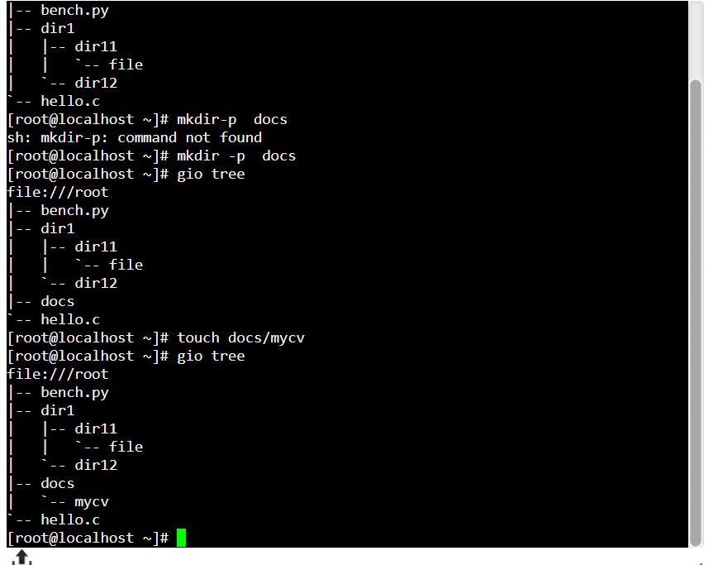

3.a - Remove dir11 in one-step. What did you notice? And how did you overcome that?

I noticed that I can’t remove the directory because it has a content., to solve this problem we use -r with rm command .

3.b -Then remove dir12 using rmdir –p command. State what happened to the hierarchy (Note: you are in your home directory). ? 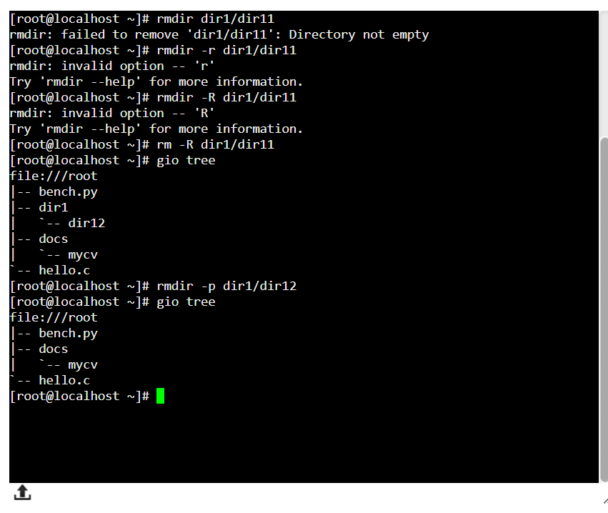

What happened here is that the parent directory of the dir 12 is deleted too so the command rmdir -p removes the directory and its parent .

3.c –The output of the command pwd was /home/user. Write the absolute and relative path for the file mycv ? -

- the relative path for myvc is /docs/mycv .

1. Copy the /etc/passwd file to your home directory making its name is mypasswd

* cp /etc/passwd /mypasswd

1. You are in /usr/bin, list four ways to go to your home directory ?

* Cd../..
* Cd/home
* Cd Home
* Cd ~

1. List Linux commands in /usr/bin that start with letter w

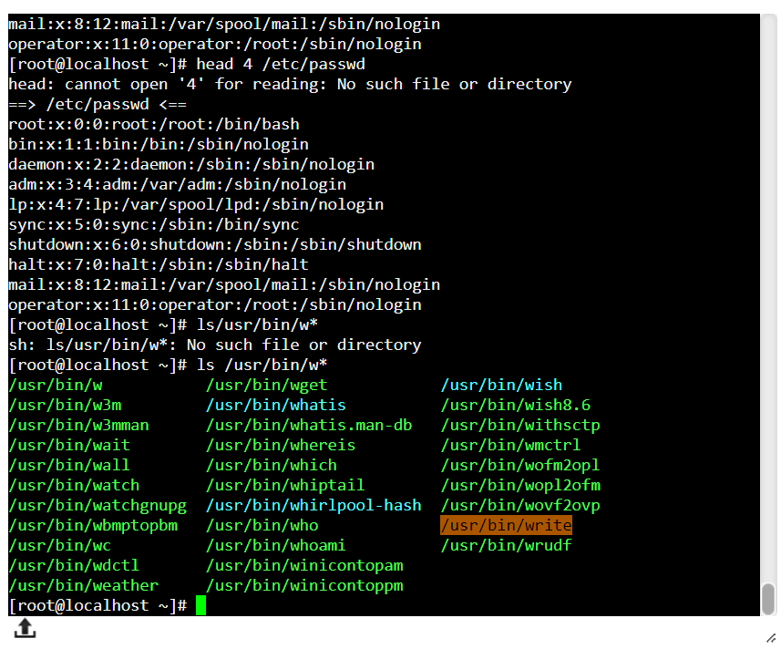

1. Display the first 4 lines of /etc/passwd ?

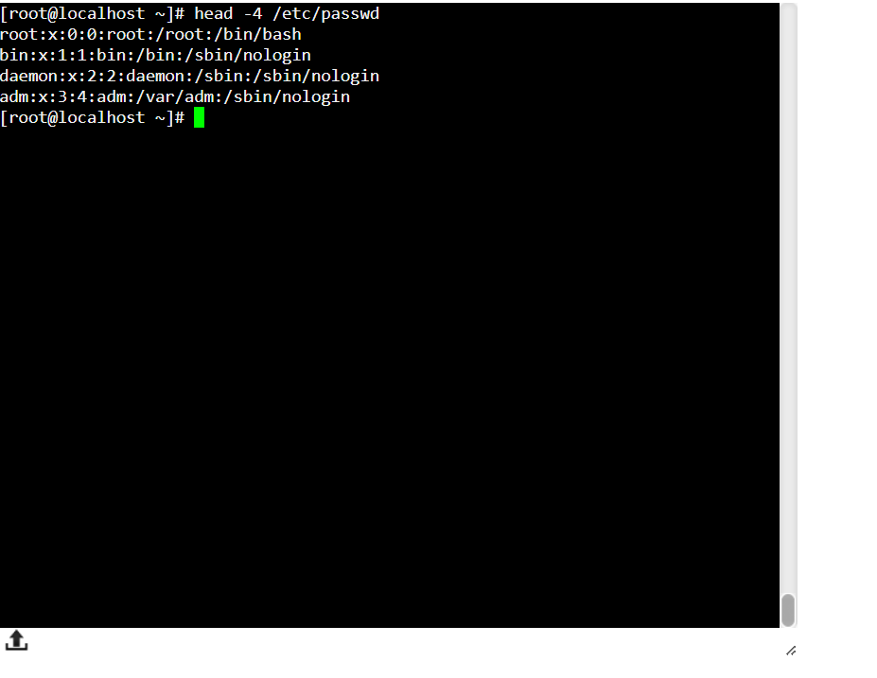

1. 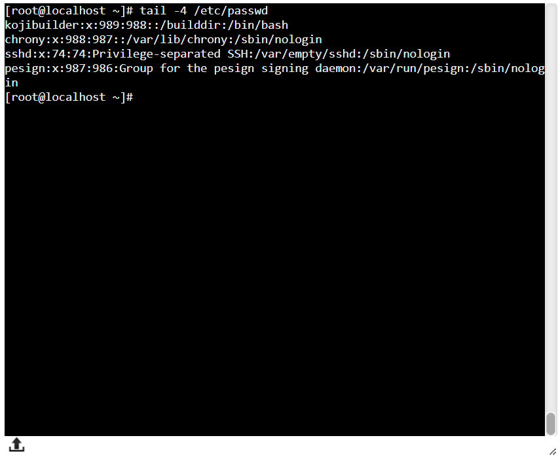Display the last 7 lines of /etc/passwd

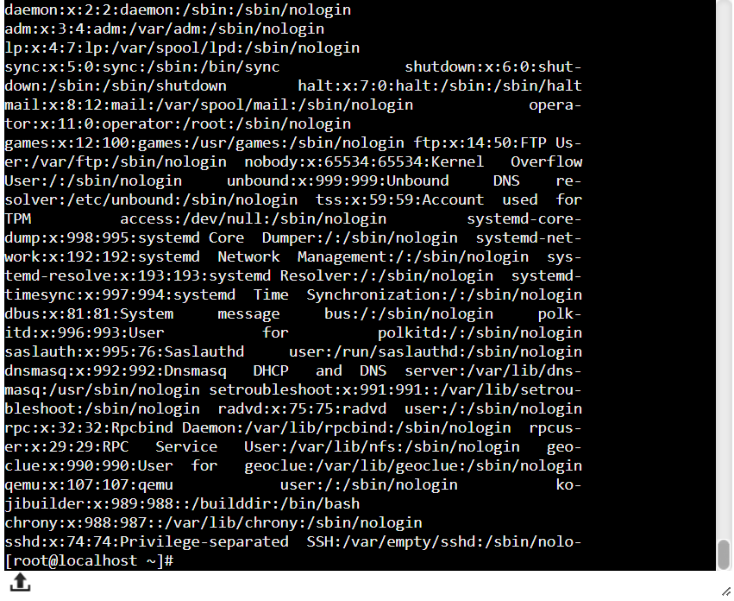9. Display the man pages of passwd the command and the file sequentially in one command.

-man passwd; man /etc/passwd

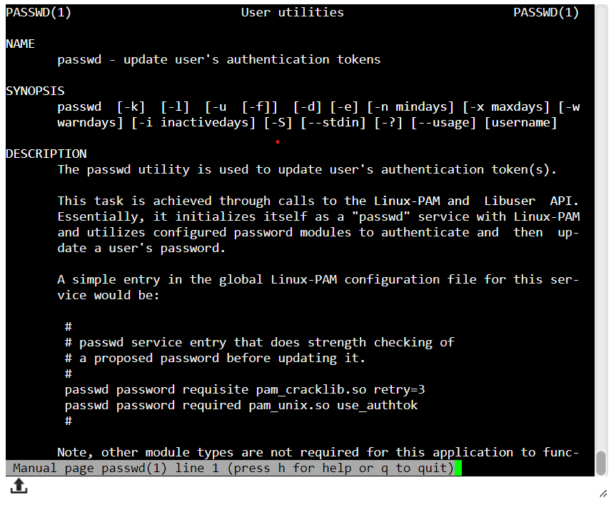

10 .Display the man page of the passwd file.

 - man /etc/passwd

11.Display a list of all the commands that contain the keyword passwd in their man page.

* Man -k passwd